Online CCA Registration
USER GUIDE for
STUDENTS

Table of Contents

Login 1
CCA Registration 3
Print Confirmation Slip 5
Sample Confirmation Slip 6

Login
URL: https://canberra.schoolhub.sg

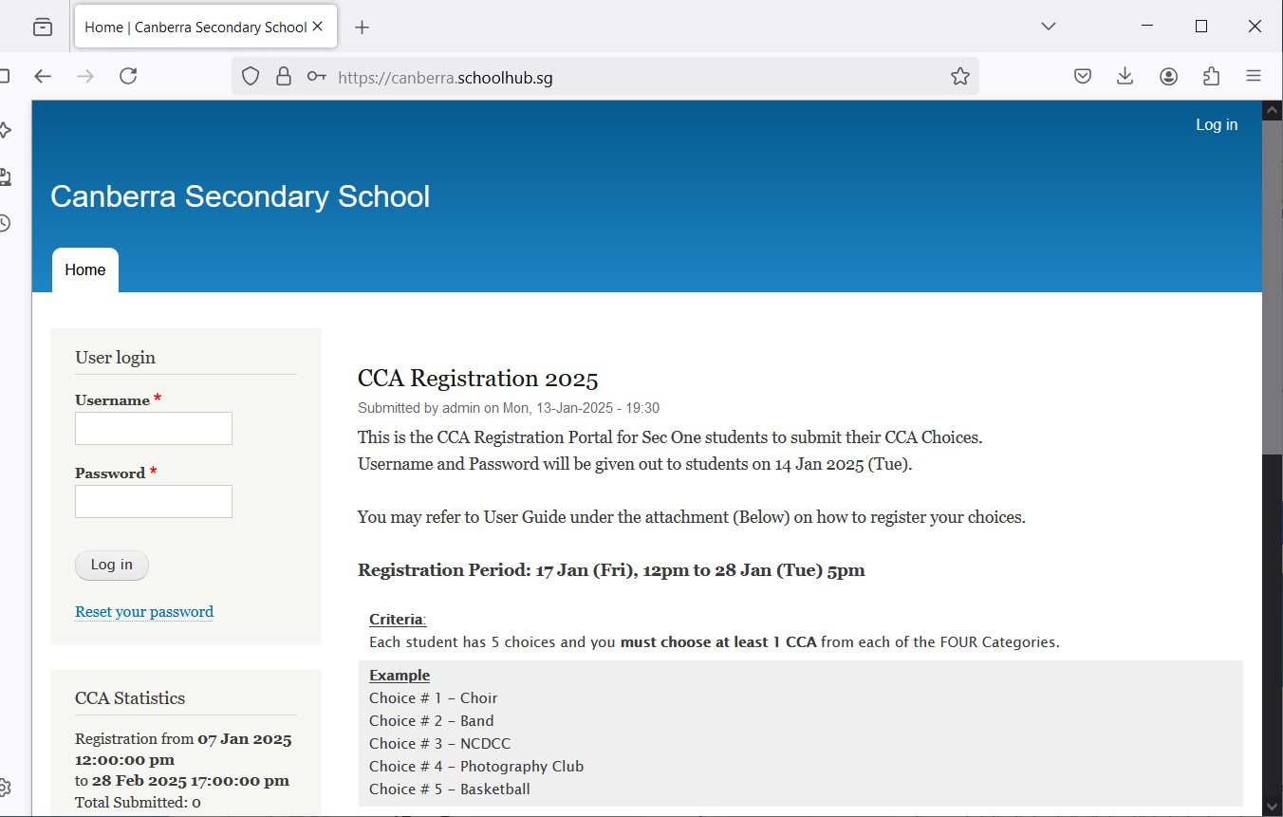

Steps
- Enter Username
- Enter Password
- Click Log in button
Upon successful login, you will be able to see the CCA Registration link under Pupil Menu.

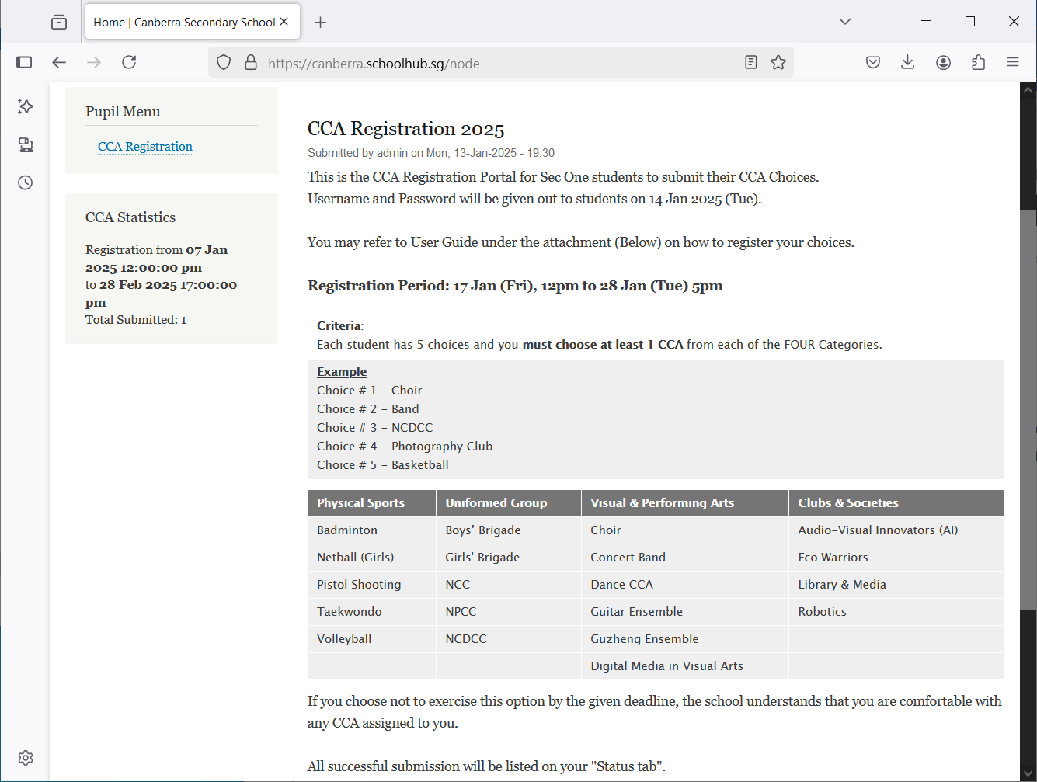
Criteria
CCA Registration

Steps
- Click on CCA Registration button to begin

CCA Registration
If you have not registered, you will see this message: “You have not submitted yet”.

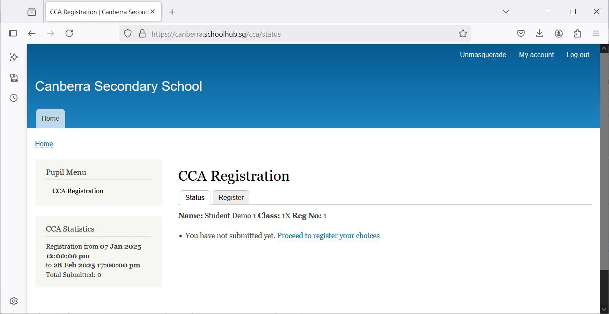
Click Register to begin

Part 1
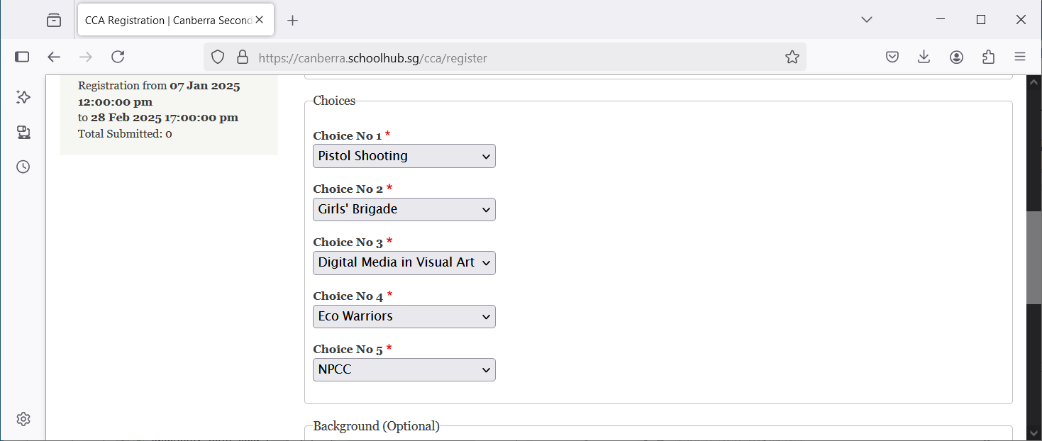
Part 2 (Optional)
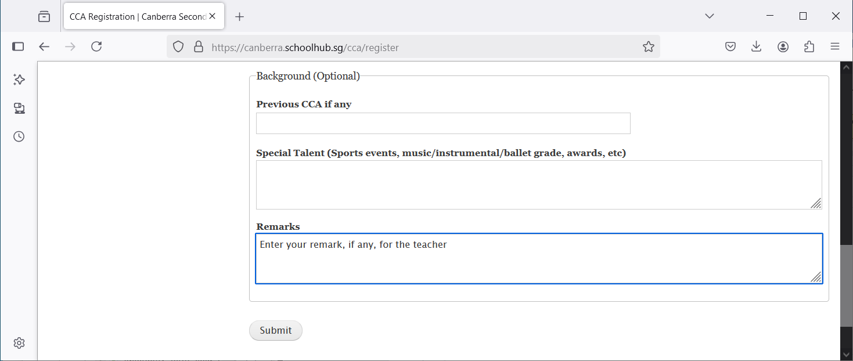
Steps
- Click on Register tab to begin
- Click Submit to Confirm

Print Confirmation Slip
Once you have clicked Submit, you will be redirected to the Status Tab where your choices will be displayed.
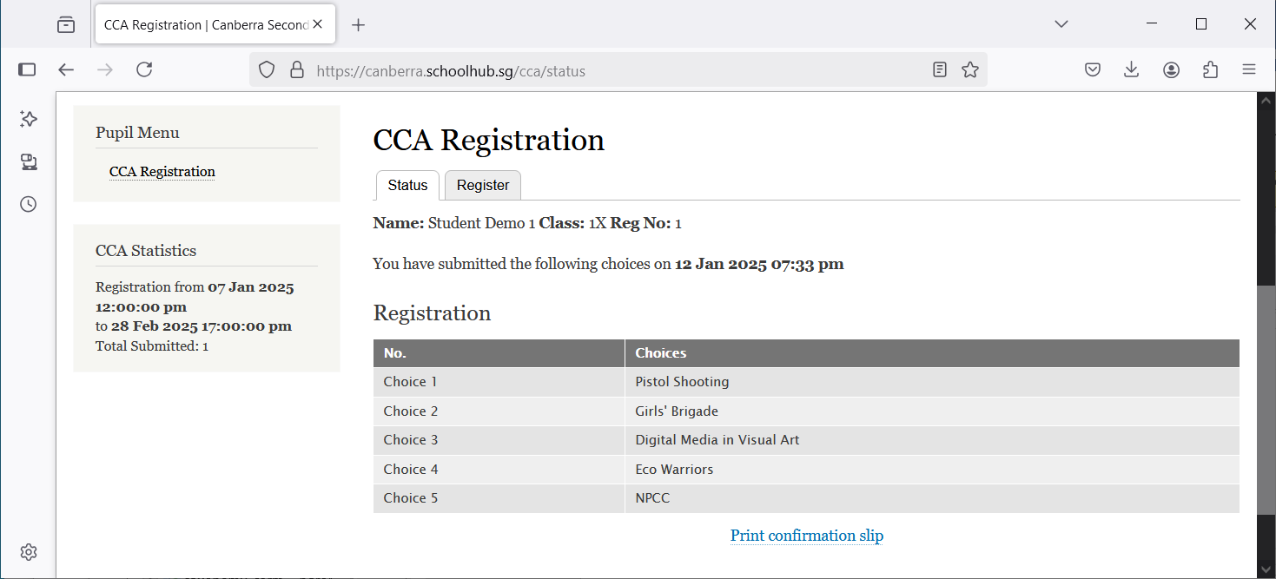

Steps
- Click Print Confirmation Slip button (to save a PDF for your reference)

Sample Confirmation Slip
